The World Happiness Story

Advanced Data Visualization and Storytelling with Python
A Visual Narrative Built on the 2015 World Happiness Report

Week 1 Task

- Introduction

This report presents an exploratory analysis of the World Happiness Report dataset , a well-known cross-country survey that ranks nations by self-reported happiness and breaks that score down into contributing factors such as economic output , social support , health,freedom,trust in government and generosity.

- Data Cleaning Steps

2.1 Missing Values
An initial null check revealed extensive missingness across nearly every numeric column(e.g Happiness score was missing in 916 of 1231 rows).Investigation showed this was not random missingness but a schema alignment issues: each year’s original release used slightly different column names, and when the files were concatenated only 2015 and 2016 files shared exact column names used in this combined file. As a result:
Rows for 2015 and 2016 (315 rows total) retained complete data for the core columns used in this analysis.
• Rows for 2017–2022 were largely blank in these columns and were excluded from the score-based
visualizations and correlation analysis, since imputing them would misrepresent the original survey results.
• The Standard Error column was dropped from analysis — it was populated for only 158 rows (2015 only) and is
not comparable across years.
After filtering to rows with a valid Happiness Score, the working analysis dataset contains 315 country-year observations
covering the 2015 and 2016 survey rounds.

2.2 Data Types
Numeric fields (Happiness Rank, Happiness Score, Economy, Family, Health, Freedom, Trust, Generosity, Dystopia
Residual, year) were already stored as float64/int64 and required no conversion. Country and Region were kept as text
(string) fields. The unlabeled index column ("Unnamed: 0") was identified as a leftover row index from the source CSV
and dropped, as it carried no analytical value.

2.3 Duplicate Rows
A full-row duplicate check returned zero duplicate records. A secondary check for duplicate Country + year combinations
within the cleaned 315-row dataset also returned zero duplicates, confirming each country appears at most once per survey
year.

- Visualization & Analysis

3.1 Distribution of World Happiness Score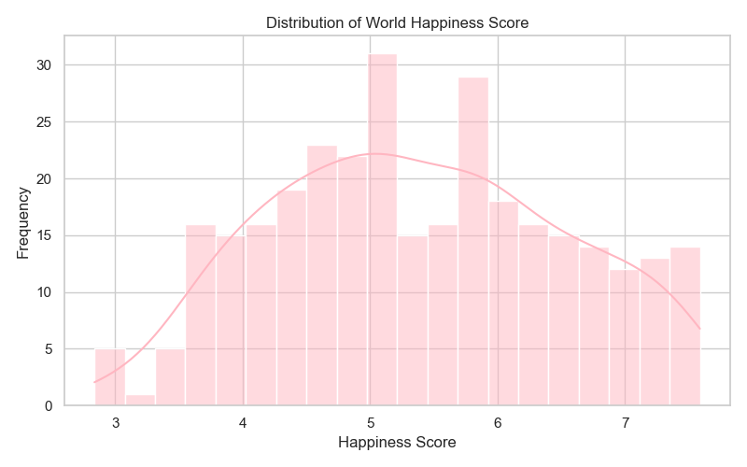
The histogram shows happiness scores spread across a wide range, from roughly 2.8 to 7.6, with a mean near 5.4. The
distribution is fairly broad and slightly bimodal rather than sharply peaked, with concentrations of countries around the
5.0 and 5.8–6.0 marks. This indicates the global population of countries does not cluster tightly around one happiness level
— there is a genuine and fairly continuous spread from low-scoring to high-scoring nations, consistent with real economic
and social disparities between regions.

3.2 Boxplot of Happiness Score (Outlier Detection)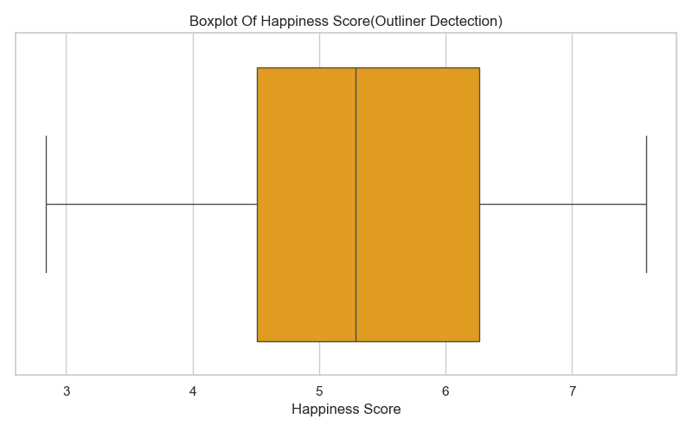
The boxplot places the median happiness score around 5.3, with the interquartile range (the middle 50% of countries)
spanning roughly 4.5 to 6.3. The whiskers extend to the dataset's minimum and maximum values with no points plotted
beyond them, meaning no statistical outliers were detected by the standard 1.5×IQR rule. The lowest-scoring countries in
the data (e.g., Togo and Burundi) and the highest-scoring (e.g., Switzerland, Iceland, and Denmark) are extreme relative to the median but still fall within the expected statistical range - they are genuinely low or high happiness countries rather than data errors

3.3 Correlation Matrix of Happiness Factor
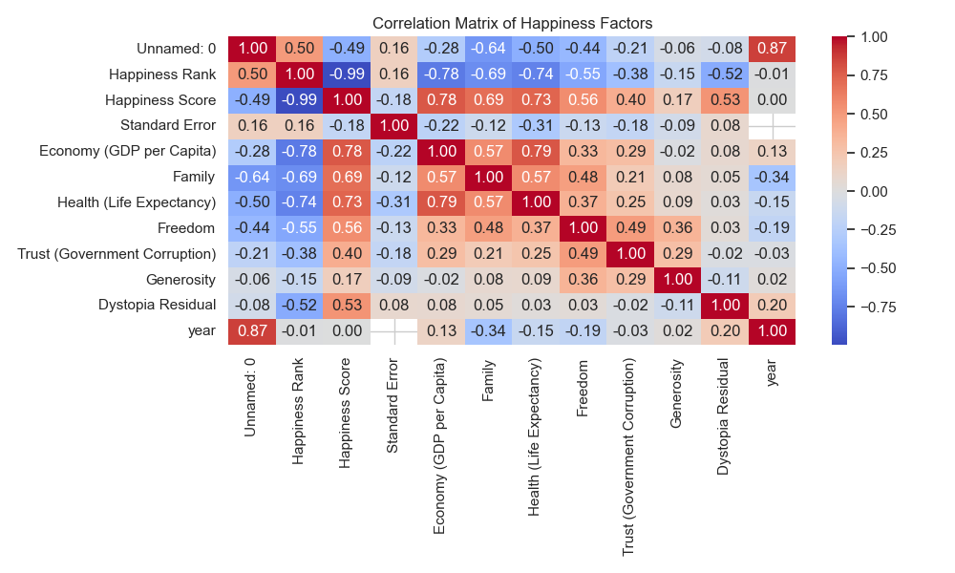
The correlation matrix shows Happiness Score has its strongest positive relationships with Economy/GDP per Capita
(0.78) and Health/Life Expectancy (0.73), followed by Family (0.69) and Freedom (0.56). Trust in Government Corruption
(0.40) and Dystopia Residual (0.53) are moderately correlated, while Generosity shows only a weak relationship (0.17).
Happiness Rank is, as expected, almost perfectly inversely correlated with Happiness Score (-0.99), since rank is derived
directly from the score. Among the underlying factors themselves, Economy and Health are strongly correlated with each
other (0.79), reflecting how national wealth and public health outcomes tend to move together.

- Summary of Key Insights

• Happiness scores in the 2015–2016 data range from 2.84 (Togo) to 7.59 (Switzerland), with a global mean of
about 5.38 and no statistical outliers — the spread reflects real cross-country differences rather than data
anomalies.
• Economic prosperity (GDP per capita) and health/life expectancy are the two factors most strongly associated
with national happiness, followed closely by strength of family/social support.
• Freedom and trust in government show moderate positive associations with happiness, while generosity has
only a weak relationship — a country's happiness level is not strongly explained by how generous its population
reports being.
• Data availability was uneven across survey years due to inconsistent column naming across the original yearly
files; only the 2015 and 2016 rounds could be reliably used for the score-based and correlation analyses, so
these findings represent that period specifically rather than the full 2015–2022 span.
• Overall, the data supports the report's central narrative: happiness is a multi-dimensional outcome most closely

